EXPERIMENTS 12–17 [VMWARE]

Student Name | Tharunkumar.S
Register Number | 192511416
Software | VMware Workstation Pro 17
Guest Operating System | Ubuntu Linux (64-bit)

CONTENTS

Ex. No. | Experiment Title
12 | Installation of Type-2 Hypervisor and Creation of Ubuntu VM
13 | Creation of VM with 1 CPU, 2 GB RAM and 15 GB Storage
14 | Creation and Allocation of a Virtual Hard Disk
15 | Snapshot Creation and Restoration of Previous VM State
16 | VM Cloning and Testing the Cloned VM
17 | Change VM Hardware Compatibility and Execute Simple Unix Commands

EXPERIMENT NO. 12

Demonstrate virtualization by installing a Type-2 hypervisor and creating/configuring an Ubuntu virtual machine.

AIM
To install VMware Workstation on a host operating system and create, configure and launch an Ubuntu Linux guest virtual machine.

REQUIREMENTS
Windows host with hardware virtualization enabled; VMware Workstation Pro 17; Ubuntu Linux 64-bit ISO; available CPU, RAM and disk space.

THEORY
A Type-2 (hosted) hypervisor is an application running above a conventional host operating system. It creates isolated virtual machines by presenting virtualized processor, memory, network and storage resources to each guest. VMware Workstation is one example.

PROCEDURE
Step 1. Open VMware Workstation Pro and select “Create a New Virtual Machine” on the home screen.
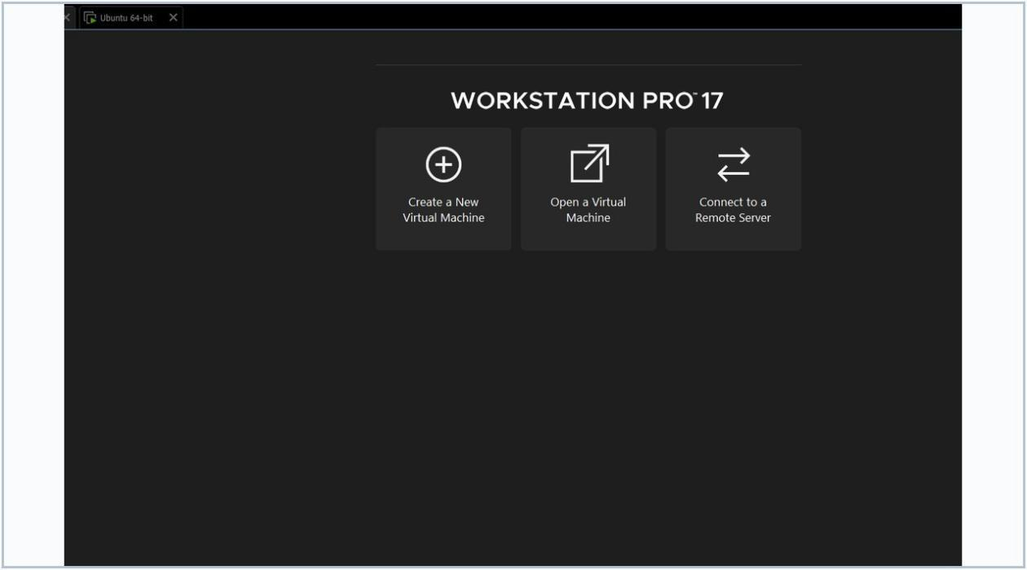
Snap 1 — VMware Workstation home page • User-provided screenshot

Step 2. In the New Virtual Machine Wizard, select “Typical (recommended)” and click Next.
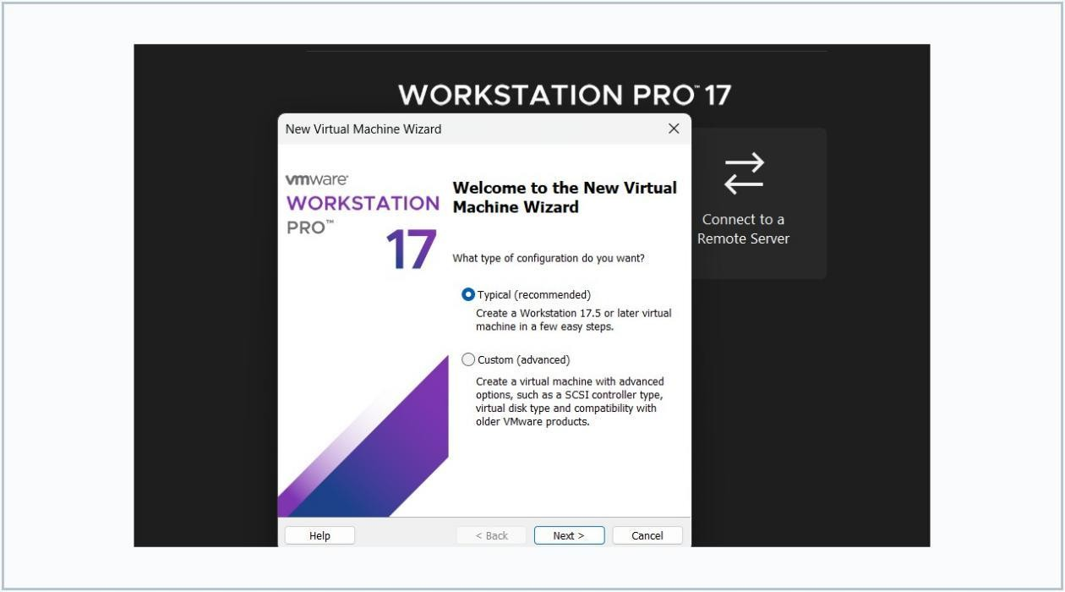
Snap 2 — Welcome to the VM wizard • User-provided screenshot
Step 3. Choose “Installer disc image file (iso)”, browse to the Ubuntu ISO, verify the detected guest OS and click Next.
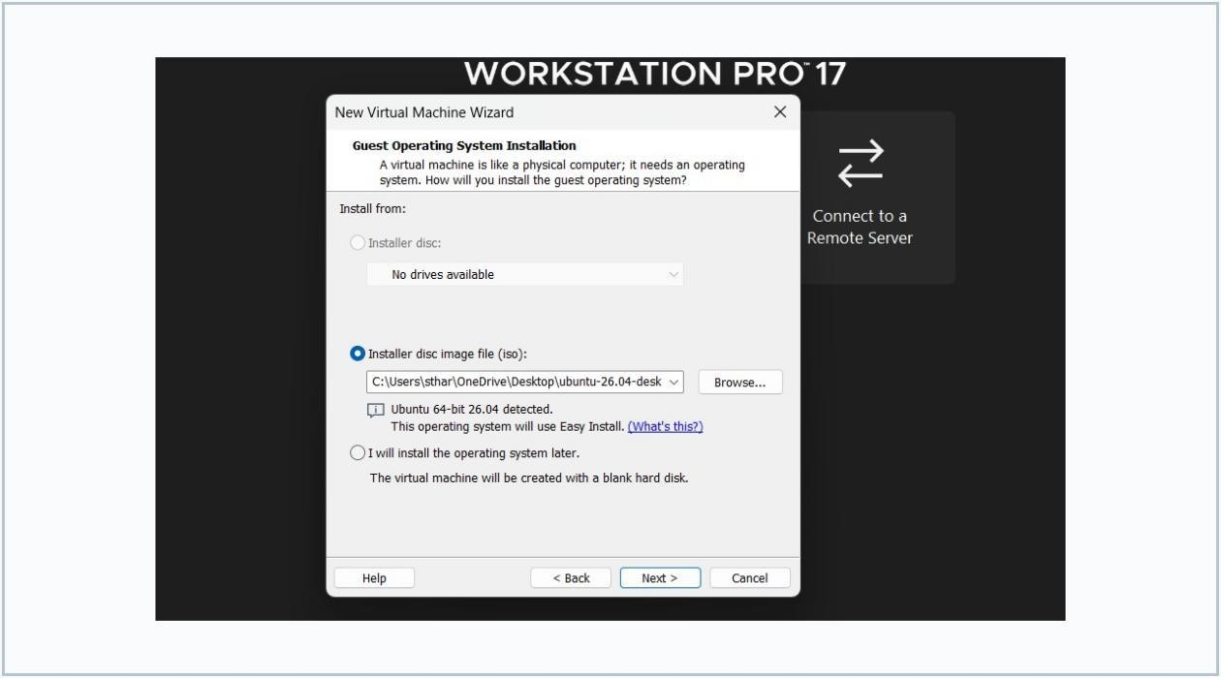
Snap 3 — Guest OS installation source • User-provided screenshot
Step 4. If prompted for Easy Install details, enter the Linux user name and password. Keep those credentials secure.

Step 5. Enter a descriptive VM name, choose a host storage location and click Next.
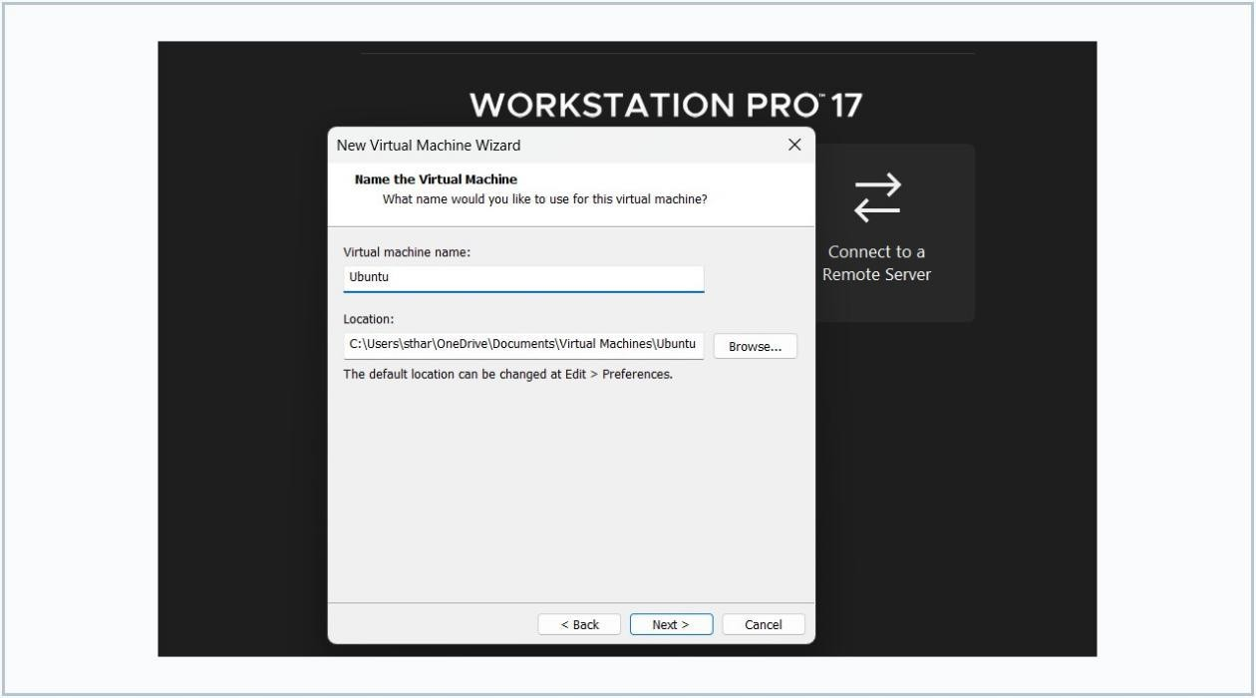
Snap 5 — Virtual machine naming wizard • User-provided screenshot
Step 6. Specify a virtual disk capacity (20 GB shown in this experiment), choose single-file or split-file storage, then click Next.
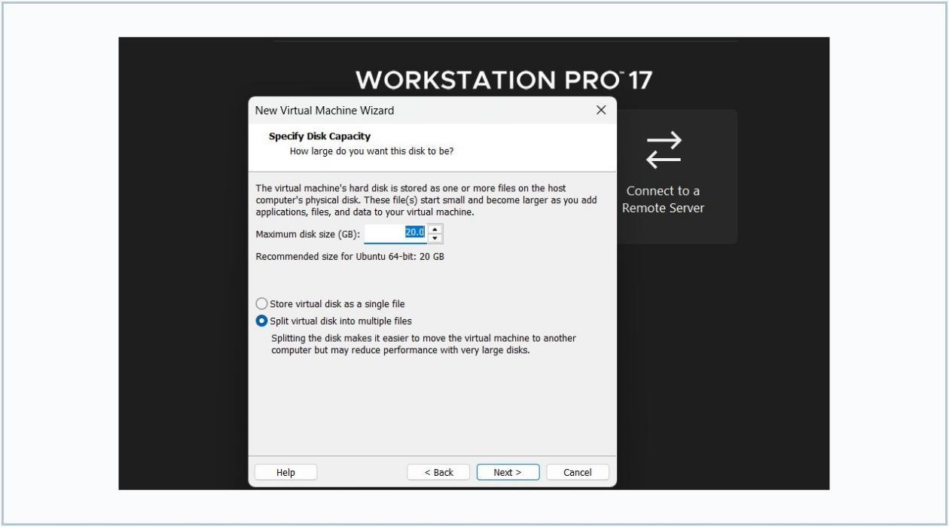
Snap 6 — Virtual disk capacity • User-provided screenshot
Step 7. Open Customize Hardware to check memory, processor count, network mode and boot ISO attachment as needed.
Step 8. Click Finish to create the VM and power it on.
Step 9. Follow the Ubuntu installer: select language, keyboard, installation preferences and target virtual disk.
Step 10. Restart the guest when installation finishes, log in and confirm that the Ubuntu desktop opens.

RESULT / VERIFICATION
VMware Workstation was opened; Ubuntu installation media was selected; a named VM with virtual storage was specified. Verify successful Ubuntu boot on the actual system. The procedure to install a hosted hypervisor and create/configure an Ubuntu virtual machine was demonstrated.

EXPERIMENT NO. 13

Create a virtual machine with 1 CPU, 2 GB RAM and 15 GB storage using Type-2 virtualization software.

AIM
To create and configure a virtual machine with exactly one virtual CPU, 2048 MB of virtual RAM and a 15 GB virtual disk in VMware Workstation.

REQUIREMENTS
VMware Workstation Pro 17; Windows host; Ubuntu 64-bit ISO; at least 15 GB available host storage plus overhead.

THEORY
Virtual hardware is allocated from physical host resources. Processor count controls guest vCPU allocation, memory defines guest RAM availability, and a virtual disk file (VMDK) stores the guest data.

PROCEDURE
Step 1. Launch VMware Workstation and select Create a New Virtual Machine.
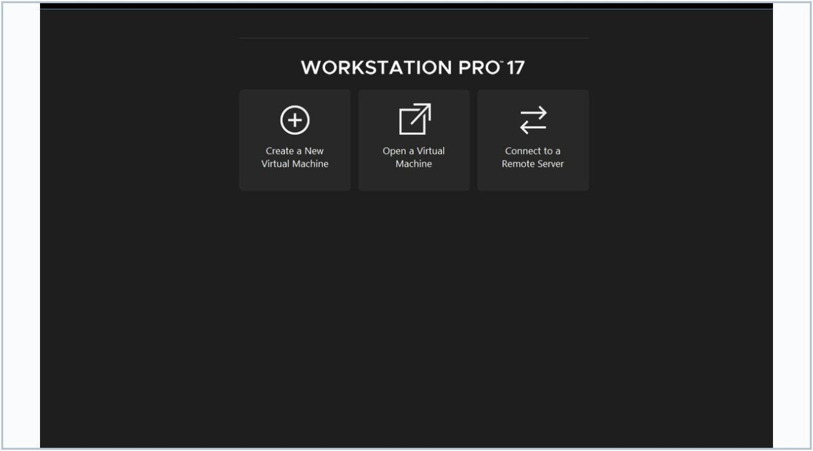
Snap 1 — VMware home page • User-provided screenshot

Step 2. Choose Typical (recommended) in the New Virtual Machine Wizard, then click Next.
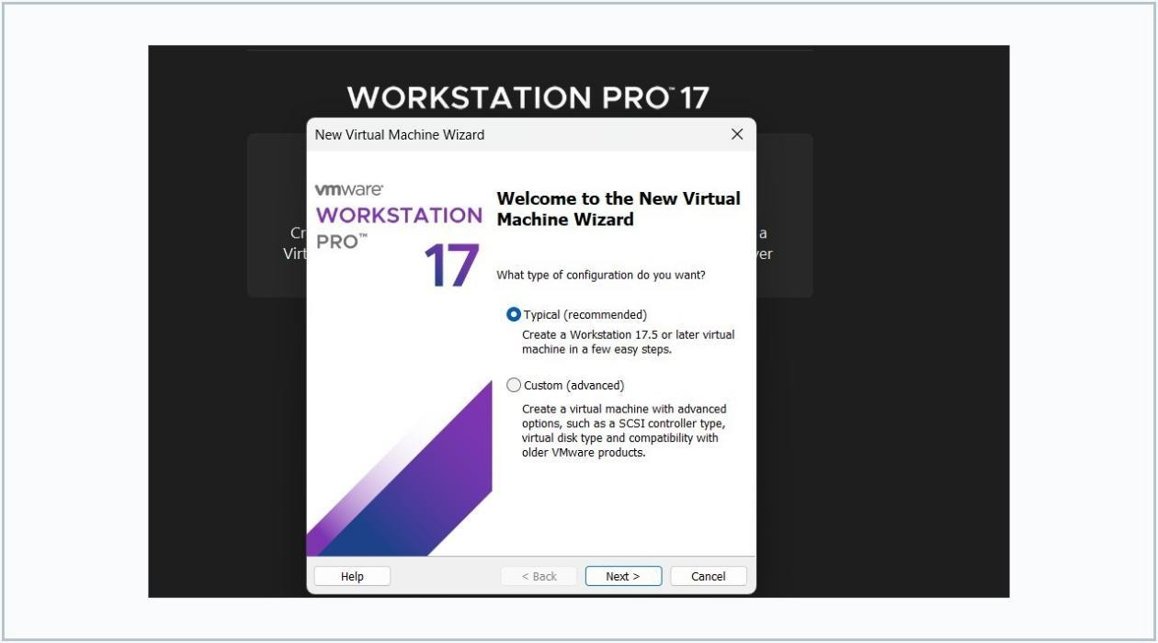
Snap 2 — Typical configuration • User-provided screenshot
Step 3. Select Ubuntu Linux installation media by browsing to the ISO file, then click Next.
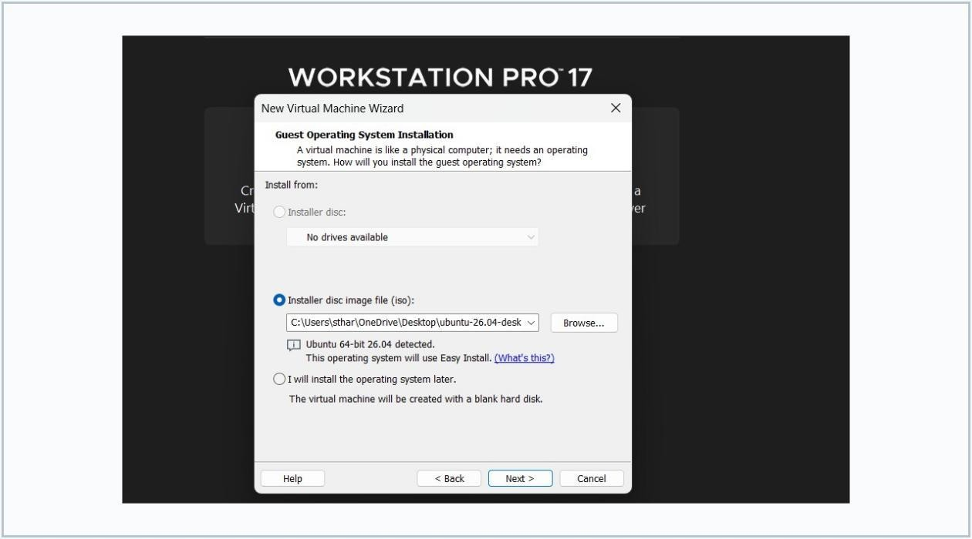
Snap 3 — Ubuntu ISO selection • User-provided screenshot

Step 4. Name the VM “Ubuntu-VM”, select its storage location and click Next.
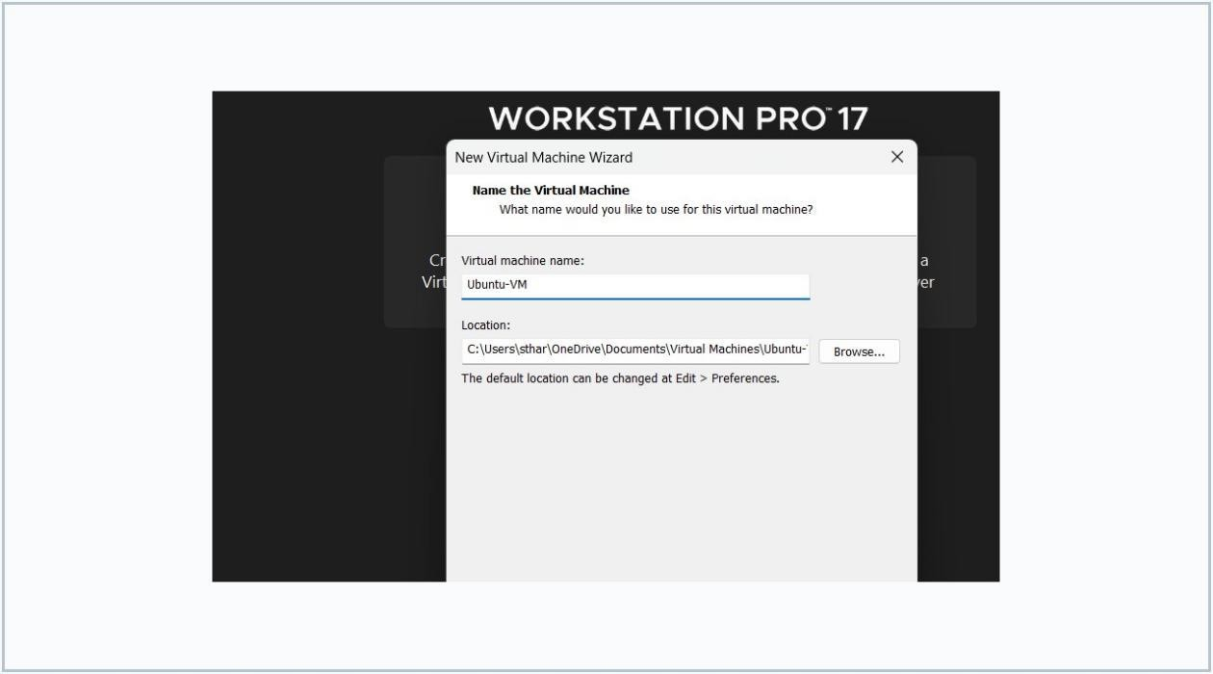
Snap 4 — Name the new VM • User-provided screenshot
Step 5. Enter 15 GB as the virtual disk capacity, select Store virtual disk as a single file and click Next.
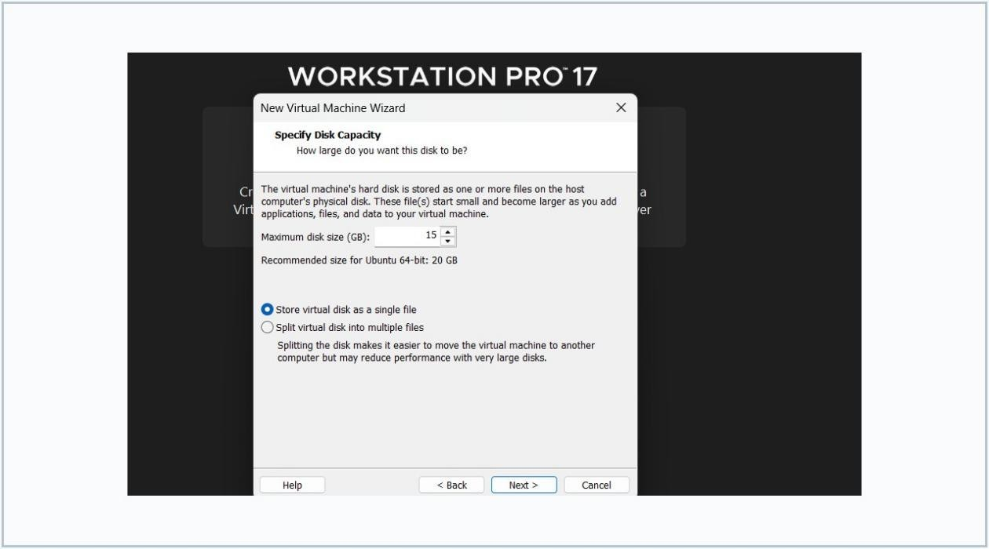
Snap 5 — 15 GB virtual disk • User-provided screenshot

Step 6. Open Customize Hardware. Configure Processors to one virtual CPU and Memory to 2048 MB (2 GB). Retain the required disk and ISO attachment, then save.
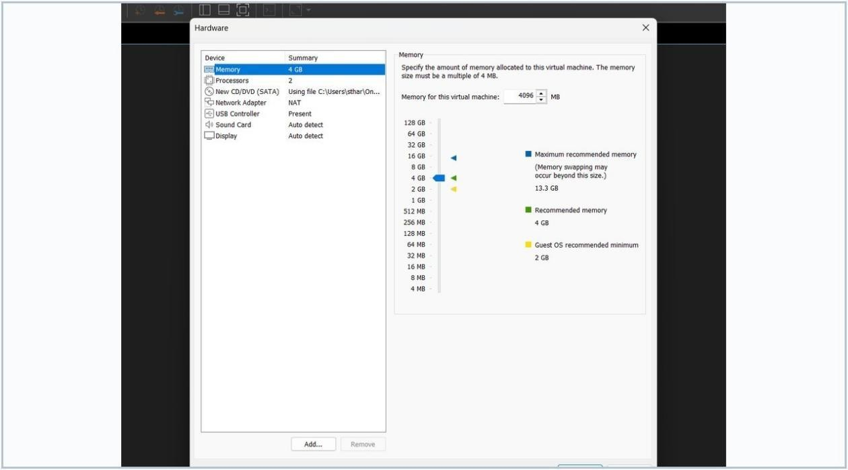
Snap 6 — VMware hardware customization panel • User-provided screenshot
Step 7. Finish VM creation, power it on, and follow the guest OS installation wizard.
Step 8. Verify the VM hardware properties in VMware Settings: CPU = 1, RAM = 2048 MB and disk = 15 GB.

RESULT / VERIFICATION
Required hardware configuration: 1 vCPU, 2 GB RAM, 15 GB virtual storage. Verify these values in VM Settings after saving. A virtual machine was configured according to the required processor, memory and storage specifications.

EXPERIMENT NO. 14

Create a Virtual Hard Disk and allocate storage using VMware Workstation.

AIM
To create an additional 15 GB VMDK virtual hard disk and attach it to a virtual machine using VMware Workstation.

REQUIREMENTS
VMware Workstation Pro 17; a VM in the powered-off state; sufficient free disk space on the host.

THEORY
A virtual hard disk is represented by one or more VMDK files. VMware exposes the virtual disk to the guest through a virtual disk controller; the guest can then partition, format and mount it as an additional storage device.

PROCEDURE
Step 1. Shut down the VM. Open VM > Settings and select the Hardware tab. Click Add... to attach a new device.
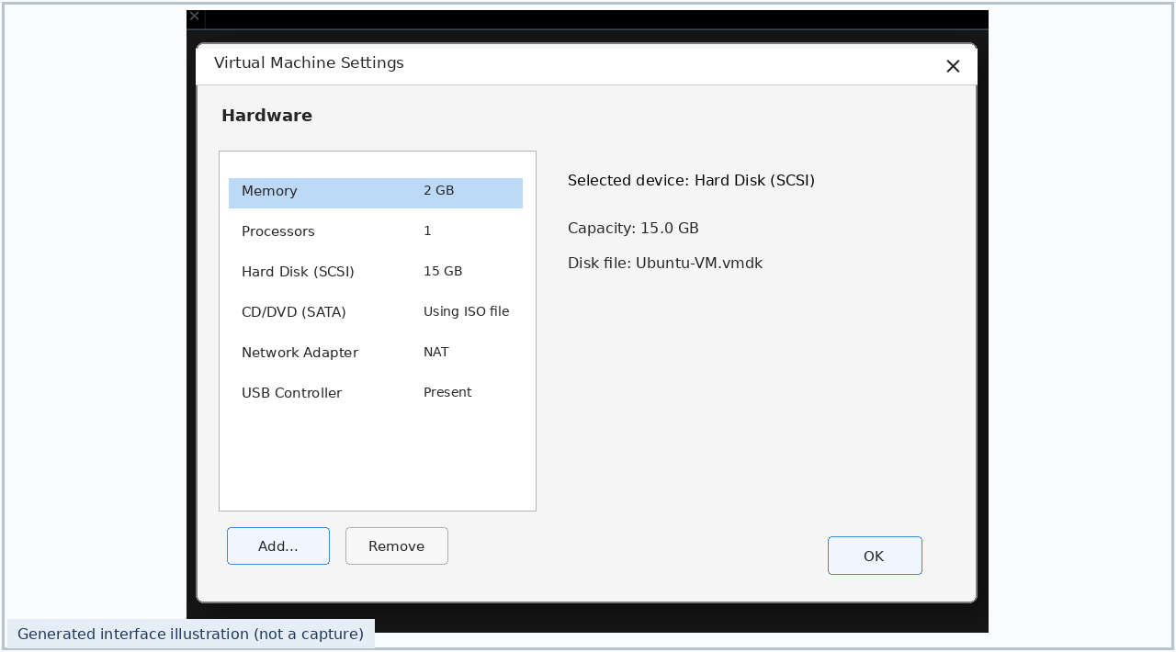
Snap 1 — Virtual Machine Settings • Illustrative interface

Step 2. Select Hard Disk from the Add Hardware Wizard and click Next. Choose a supported virtual controller type when prompted.
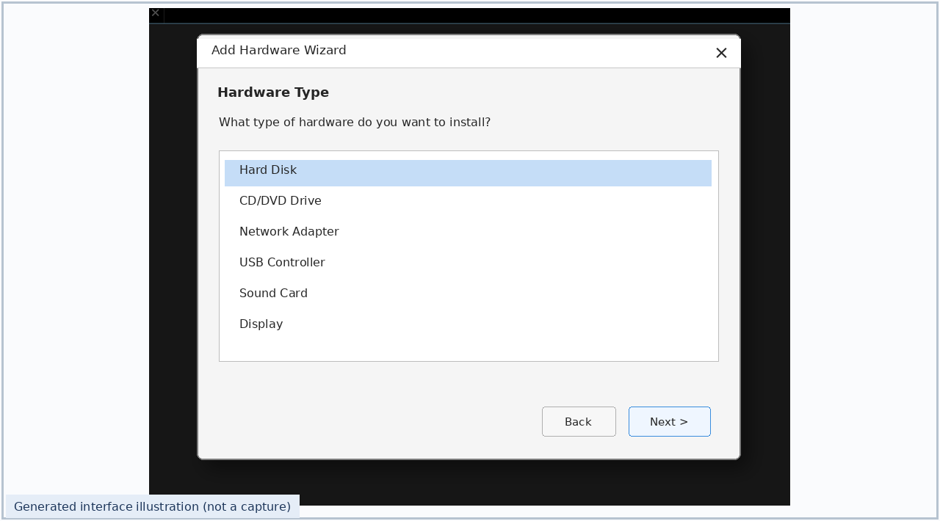
Snap 2 — Add Hardware Wizard: Hard Disk • Illustrative interface
Step 3. Choose Create a new virtual disk rather than using an existing VMDK file.
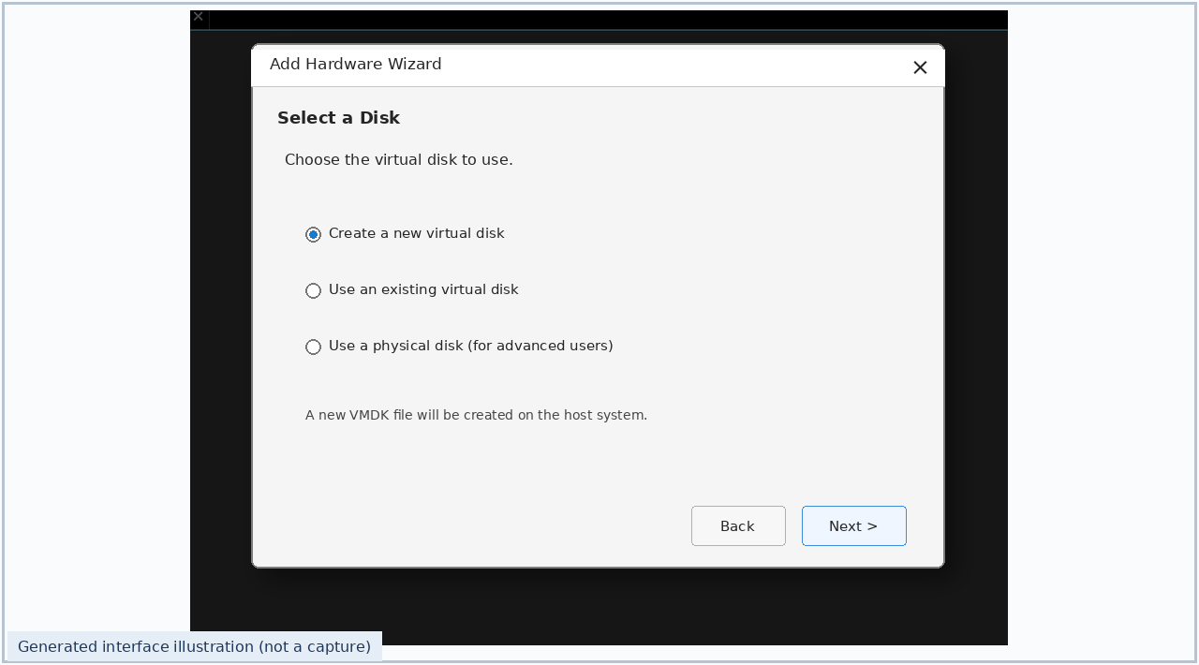
Snap 3 — Create new virtual disk • Illustrative interface

Step 4. Set maximum disk capacity to 15 GB. Leave “Allocate all disk space now” unchecked for a growable VMDK, or select it if immediate host-space allocation is required. Choose a single disk file or multiple split files, then click Next.
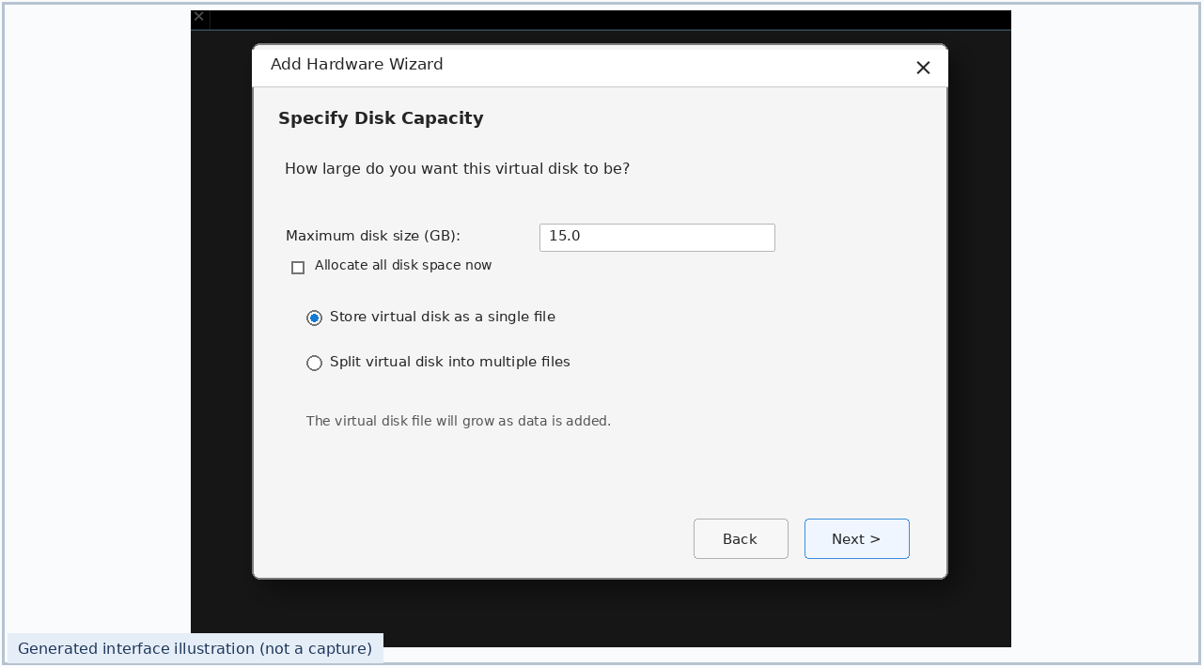
Snap 4 — Virtual hard disk capacity • Illustrative interface
Step 5. Assign a virtual disk filename (for example, Ubuntu-VM-Data.vmdk) and click Finish. Click OK in VM Settings to apply the change; verify the new hard disk is listed in the Hardware tab.
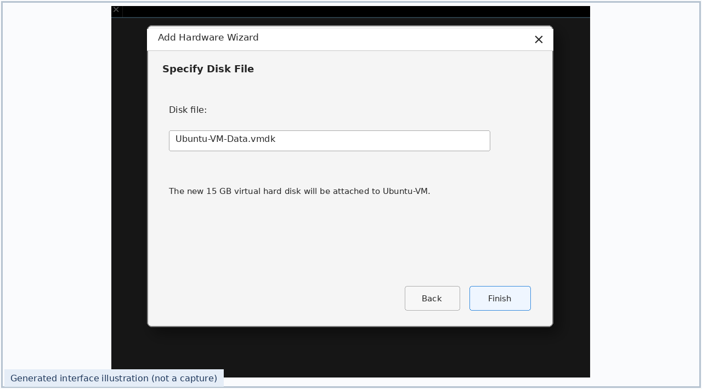
Snap 5 — Name and create the VMDK file • Illustrative interface
Step 6. Power on the VM. Run lsblk in the Ubuntu guest and identify the new 15 GB device by size. Partition, format and mount only the newly created blank disk if needed; do not format the operating-system disk.

RESULT / VERIFICATION
The VM should list an additional 15 GB virtual disk in the hardware settings; inside Ubuntu, the device should appear in the block-device list. The steps to create a 15 GB virtual hard disk and allocate it to an existing VM were demonstrated.

EXPERIMENT NO. 15

Create a Snapshot of a VM and test it by loading the previous version.

AIM
To capture the current state of a VM, make a reversible change, and restore the previous state using VMware Workstation snapshots.

REQUIREMENTS
VMware Workstation Pro 17; an existing working virtual machine; host storage capacity for snapshots.

THEORY
A snapshot records a recoverable point in a VM timeline using snapshot metadata and delta virtual disks. Reverting restores the VM to that point in time. A snapshot is not a replacement for a full backup.

PROCEDURE
Step 1. Select the VM, open VM > Snapshot and choose Take a Snapshot.
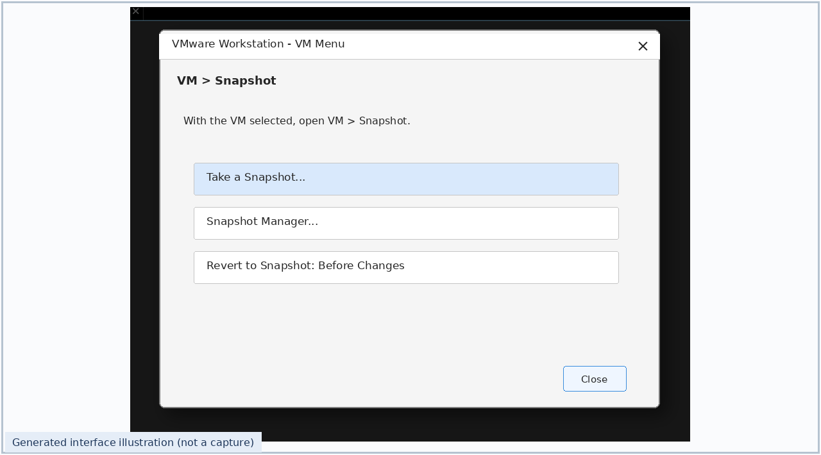
Snap 1 — VM Snapshot command • Illustrative interface

Step 2. Provide a snapshot name such as “Before Changes” and an optional description. Click OK to save the snapshot.
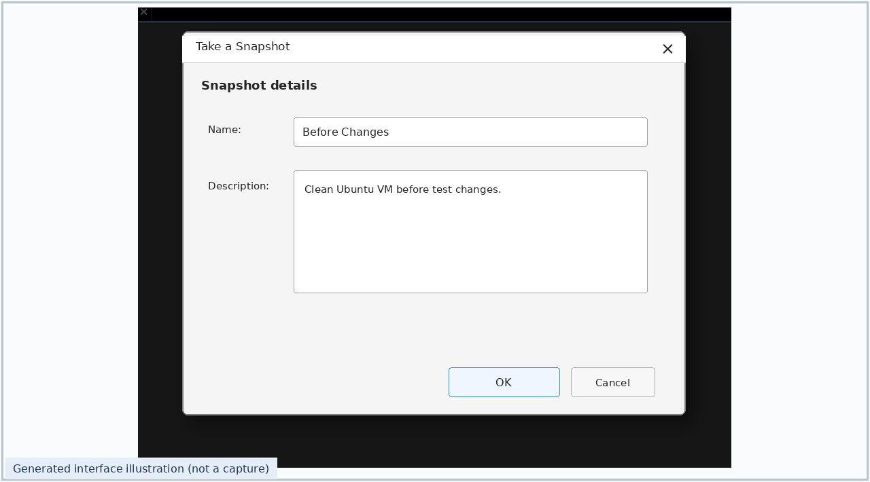
Snap 2 — Name and save the snapshot • Illustrative interface
Step 3. Make a safe, visible change in the guest (for example, create a temporary test file). Open VM > Snapshot > Snapshot Manager and select the saved snapshot.
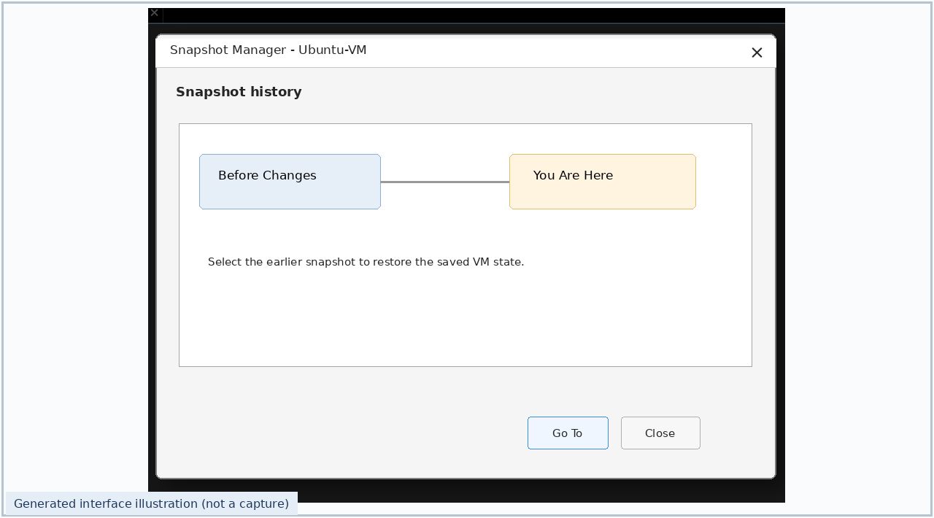
Snap 3 — Snapshot Manager • Illustrative interface

Step 4. In Snapshot Manager, select “Before Changes”, click Go To, read the warning, and confirm. To restore the immediate parent snapshot instead, use VM > Snapshot > Revert to Snapshot.
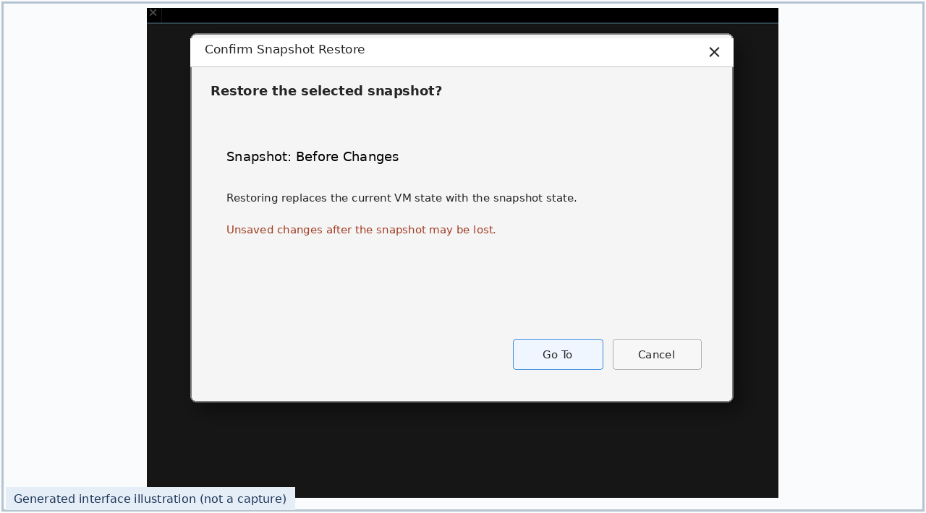
Snap 4 — Restore saved VM state • Illustrative interface
Step 5. After restoration, verify that the test change made after the snapshot is no longer present in the restored guest state.

RESULT / VERIFICATION
Snapshot name: Before Changes. Verification: a temporary test file created after taking the snapshot disappears after reverting (when the file was stored in snapshotted VM disks). A VM snapshot was created and the procedure for restoring the previous saved state was demonstrated.

EXPERIMENT NO. 16

Create a clone of a VM and test the original and cloned virtual machines.

AIM
To create a cloned virtual machine in VMware Workstation and confirm that the clone can be opened and tested separately from the original.

REQUIREMENTS
VMware Workstation Pro 17; an existing VM, sufficient host storage and a suitable power state/snapshot.

THEORY
Cloning creates a new VM derived from an existing VM or snapshot. A full clone is independent of the source VM, whereas a linked clone shares base virtual disks and therefore depends on its parent. Use different names and network identities if both instances are to run together.

PROCEDURE
Step 1. Select the source VM and open VM > Manage > Clone to launch the cloning wizard.
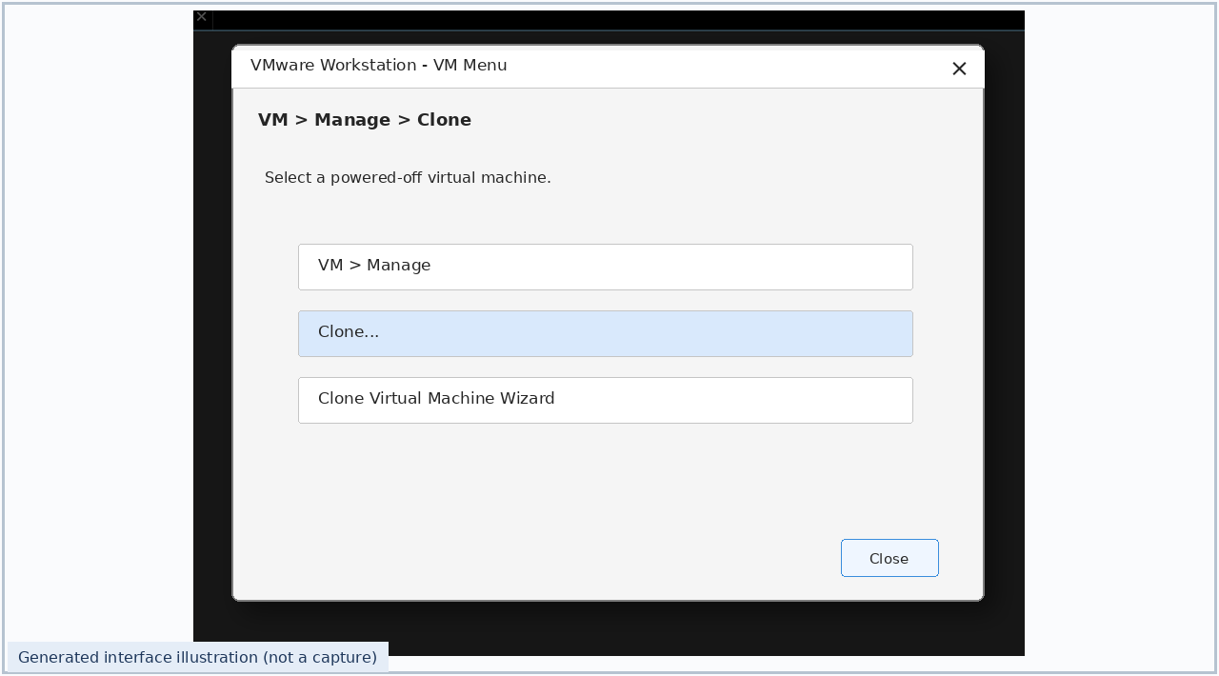
Snap 1 — Open Clone command • Illustrative interface

Step 2. Choose the source VM state (current state or an existing snapshot) and click Next. If current state is selected, VMware first creates a snapshot of the source before cloning.
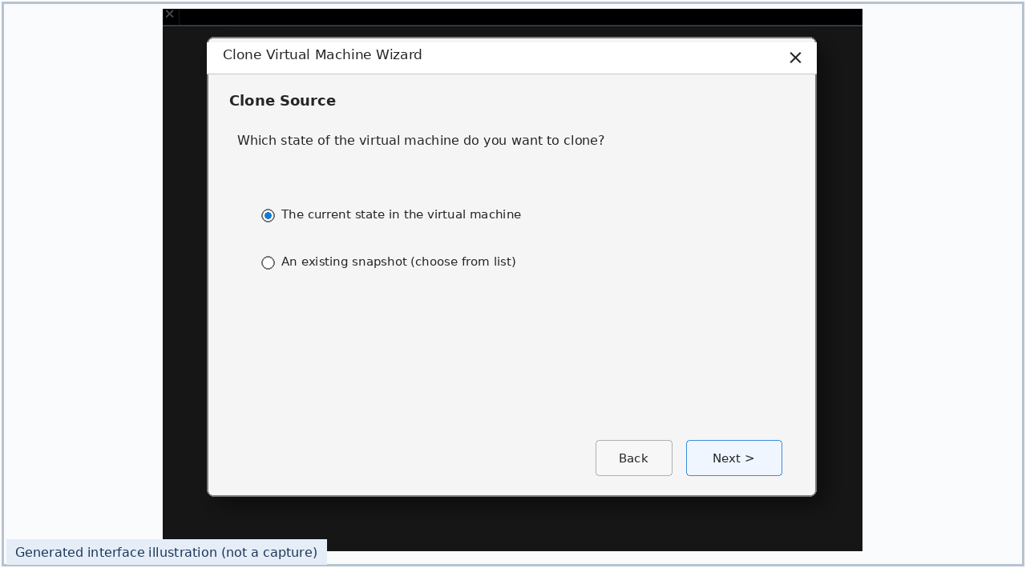
Snap 2 — Select the clone source • Illustrative interface
Step 3. Choose Create a full clone for an independent VM copy and continue.
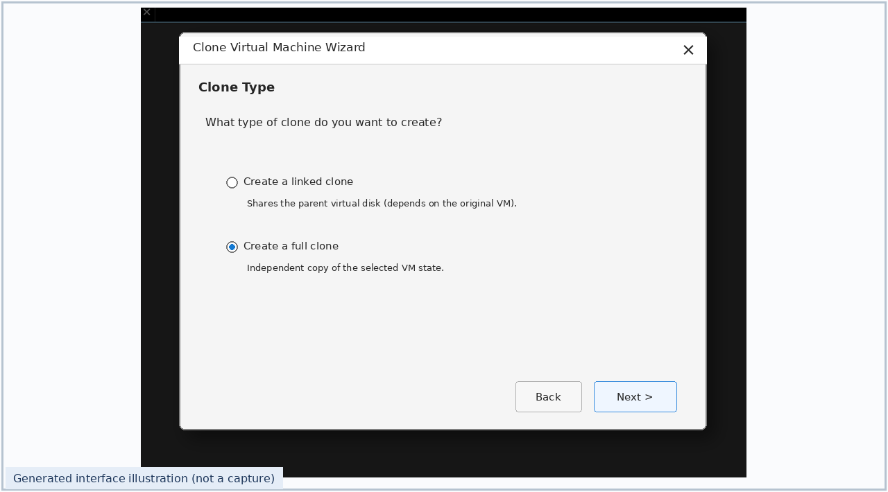
Snap 3 — Choose Full Clone • Illustrative interface

Step 4. Enter the new VM name “Ubuntu-VM-Clone”, select a separate host directory and click Finish.
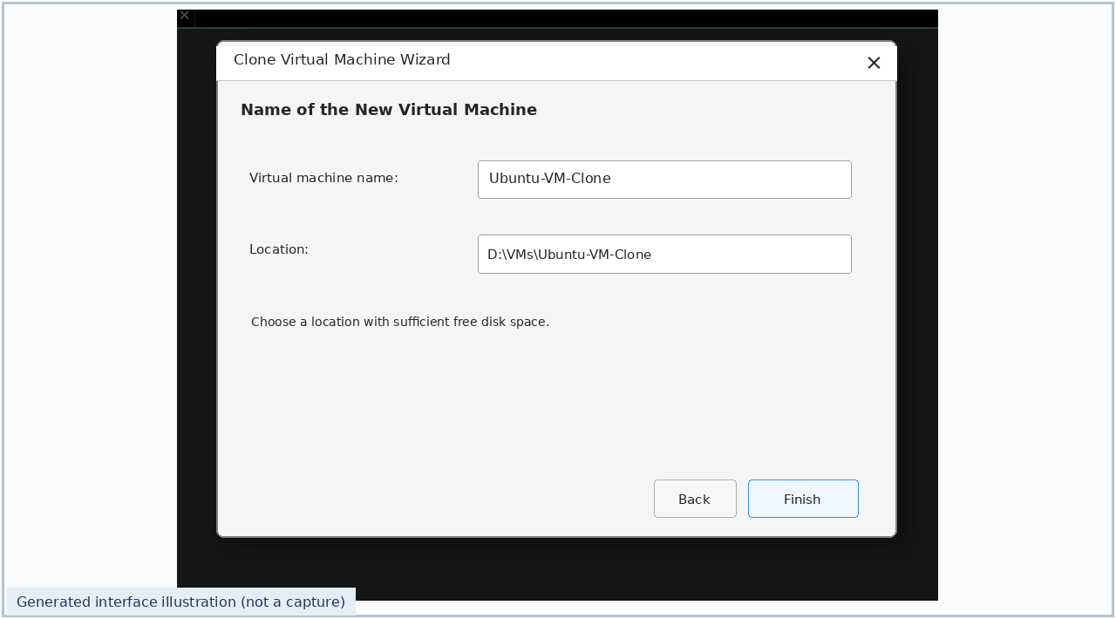
Snap 4 — Name and locate the clone • Illustrative interface
Step 5. Confirm that the cloned VM appears in the VMware library. Open the clone, power it on and verify that it boots normally.
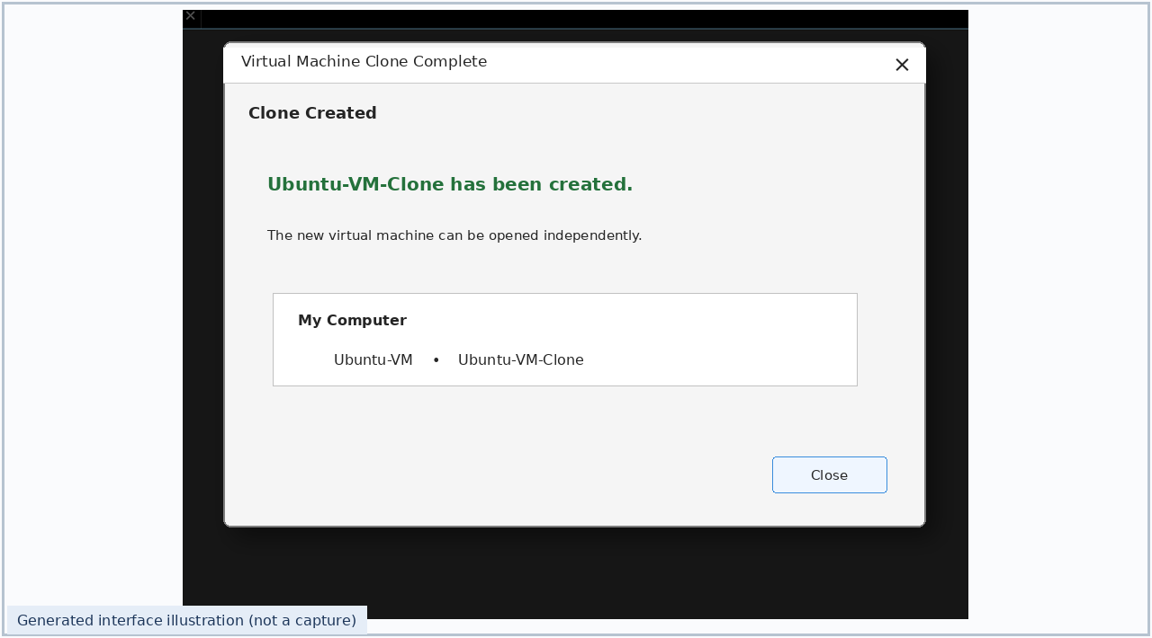
Snap 5 — Cloned VM created • Illustrative interface
Step 6. Test the source VM and cloned VM individually. If both are to run on one network, ensure their hostnames, addresses and machine identities do not conflict. You may also restore the source from a prior snapshot, if one exists.

RESULT / VERIFICATION
Expected entries in the VMware library: Ubuntu-VM (source) and Ubuntu-VM-Clone (clone). A full clone must boot without requiring the original VM virtual disk. The procedure to clone an existing VM and test the cloned and original machines independently was demonstrated.

EXPERIMENT NO. 17

Change Hardware Compatibility of an Existing Virtual Machine and Run Simple Unix Commands

AIM
To change the virtual hardware compatibility of an already created and configured Ubuntu virtual machine using VMware Workstation Pro, preserve the original virtual machine by cloning, and execute elementary Unix commands in the guest operating system.

REQUIREMENTS
VMware Workstation Pro 17; a configured Ubuntu Linux virtual machine; a source VM with a supported older hardware compatibility (for example, Workstation 16.x); enough host disk space for a full clone; a working Ubuntu Terminal.

THEORY
Virtual hardware compatibility determines the features and hardware-version capabilities exposed to a VM. VMware Workstation can upgrade a supported existing VM to a newer virtual hardware level through VM > Manage > Change Hardware Compatibility. A conversion wizard may clone the VM before conversion so the original remains unchanged. Unix commands are typed in the Ubuntu shell to inspect directories, identify the user, and create, read, copy, rename and remove files.

PROCEDURE — HARDWARE COMPATIBILITY
Step 1. Launch VMware Workstation, select the previously configured Ubuntu VM and shut down Ubuntu completely. Make a backup of important virtual disk (VMDK) files. Choose VM > Manage > Change Hardware Compatibility.
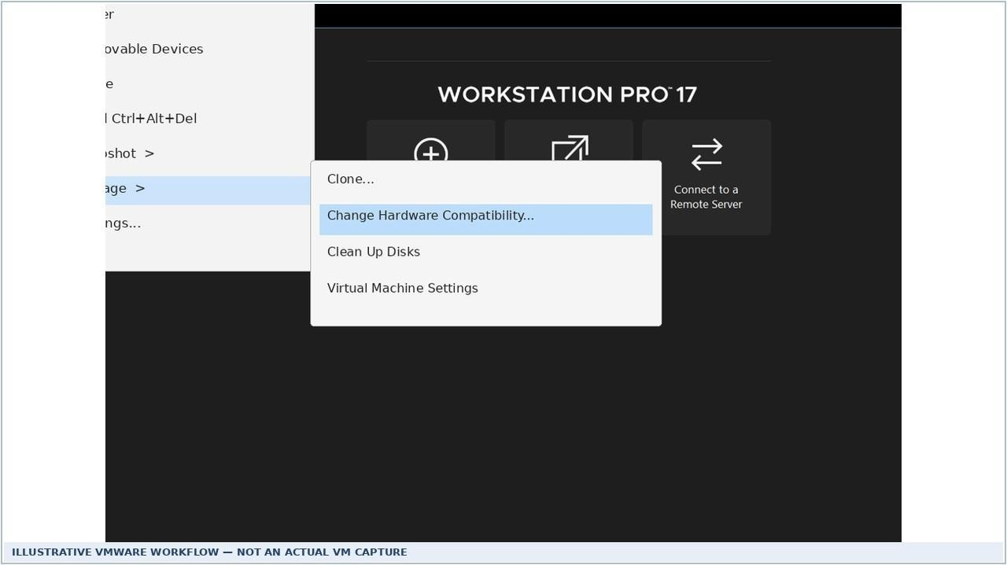
Snap 1 — Change Hardware Compatibility command • Illustrative example (not a real VM capture)

Step 2. Read the Change Hardware Compatibility Wizard introductory screen, then click Next.
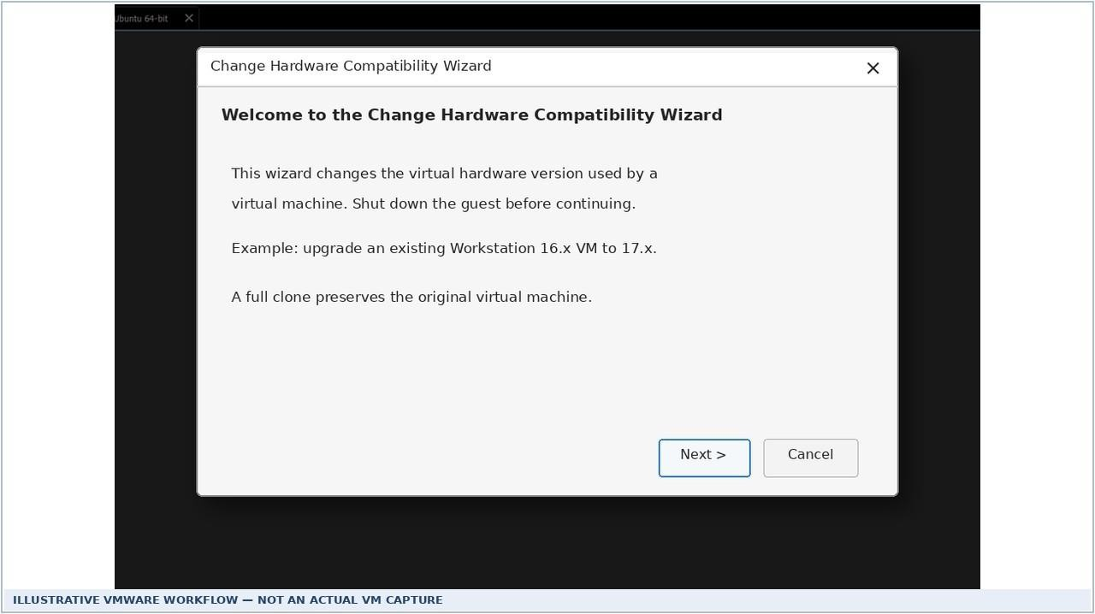
Snap 2 — Hardware compatibility welcome wizard • Illustrative example (not a real VM capture)
Step 3. In Hardware Compatibility, select Workstation 17.x as the target for an older Workstation 16.x VM (example only). The target must differ from the current version and be supported by the installed Workstation release; click Next.
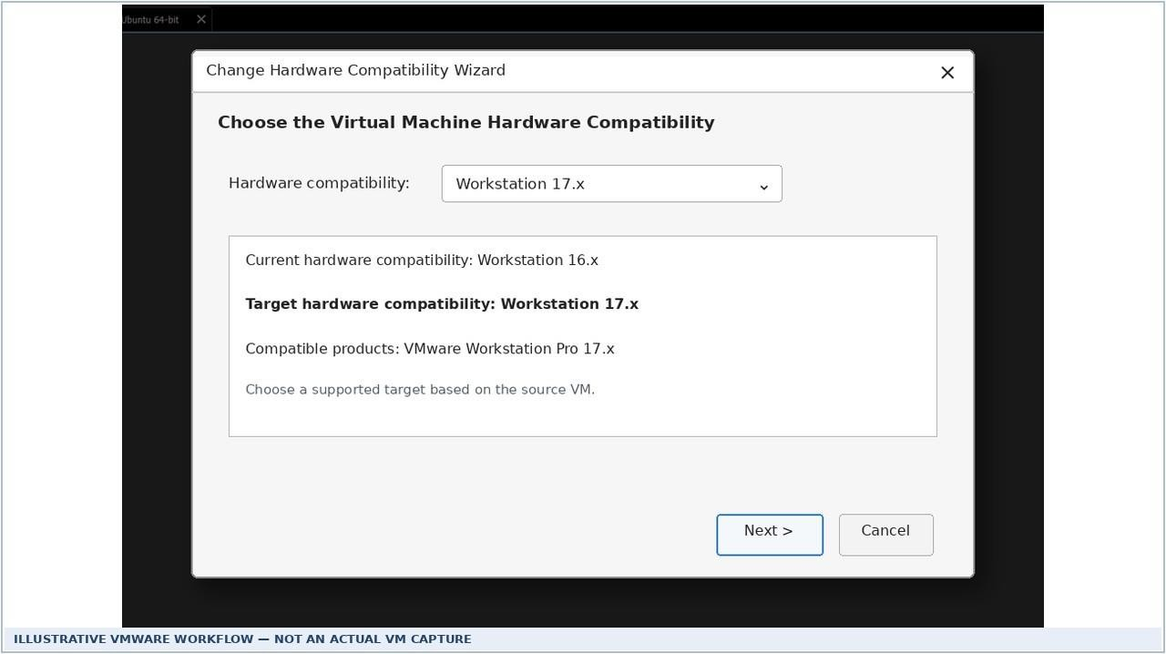
Snap 3 — Select target virtual hardware version • Illustrative example (not a real VM capture)

Step 4. Select Create a new clone of this virtual machine to preserve the source VM, then click Next. Alternatively, Alter this virtual machine changes the original VM directly and requires an independent backup.
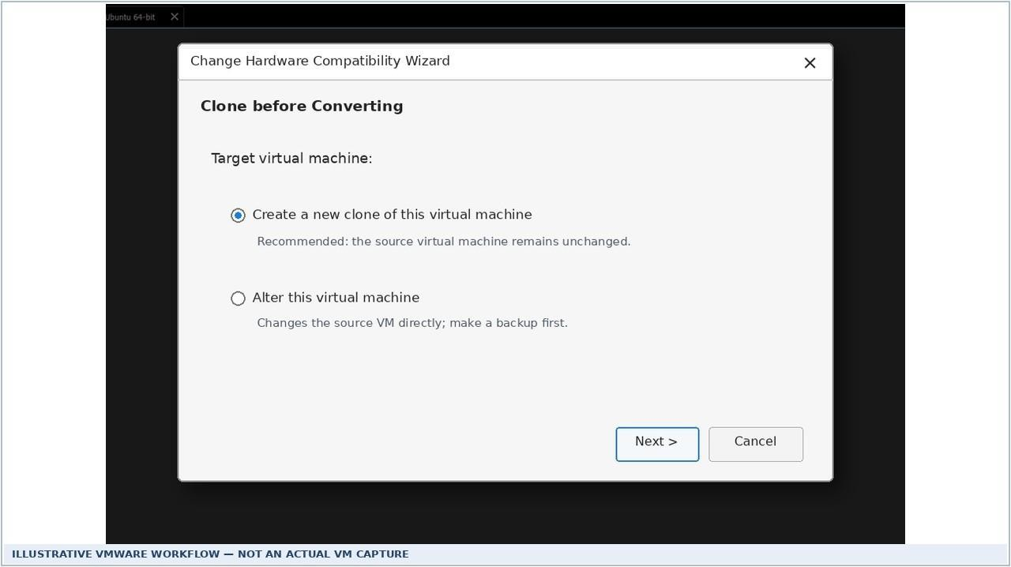
Snap 4 — Clone before converting • Illustrative example (not a real VM capture)
Step 5. Enter the name Ubuntu-Compat-17 and specify a separate storage location for the compatible clone. Click Next.
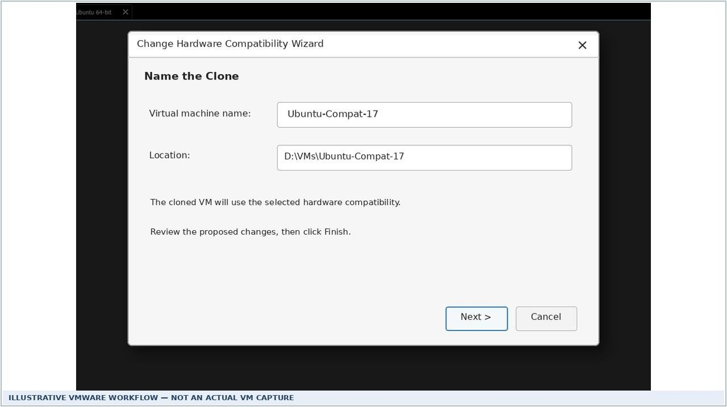
Snap 5 — Name hardware-compatible clone • Illustrative example (not a real VM capture)

Step 6. Review the source, destination and target compatibility details. Click Finish. Wait for cloning/conversion to finish, then close the wizard.
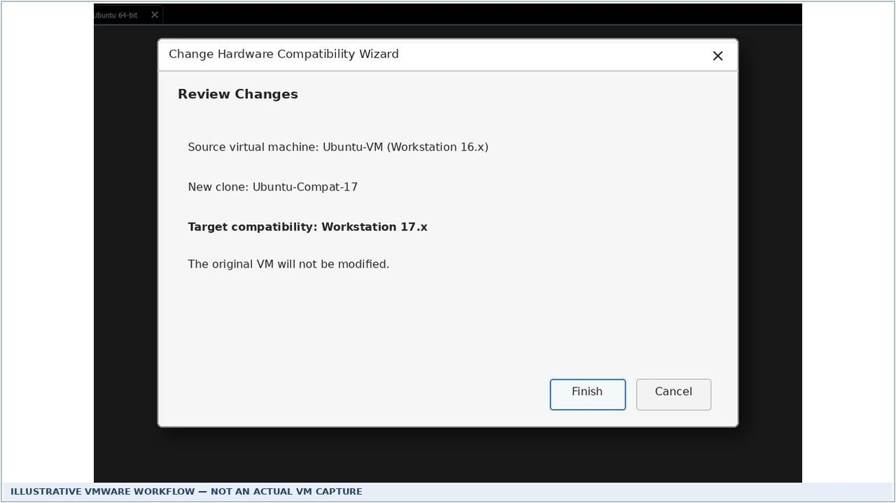
Snap 6 — Review and apply changes • Illustrative example (not a real VM capture)
Step 7. Select the converted clone in the VMware library and inspect VM Settings / Summary to verify its hardware compatibility. Power on the converted VM, log in to Ubuntu and open Terminal (Ctrl+Alt+T). If required, update VMware Tools and recheck network settings.

PROCEDURE — SIMPLE UNIX COMMANDS WITH OUTPUT
The following Unix command transcripts show typical expected output for a sample account named student. Actual paths, user names and directory contents depend on the installed Ubuntu VM. Execute these commands inside your own VM to collect real screenshots for submission.
Step 8. Run pwd to show the working directory, whoami to display the logged-in username, uname -s to display the kernel name and ls to list visible files/directories.
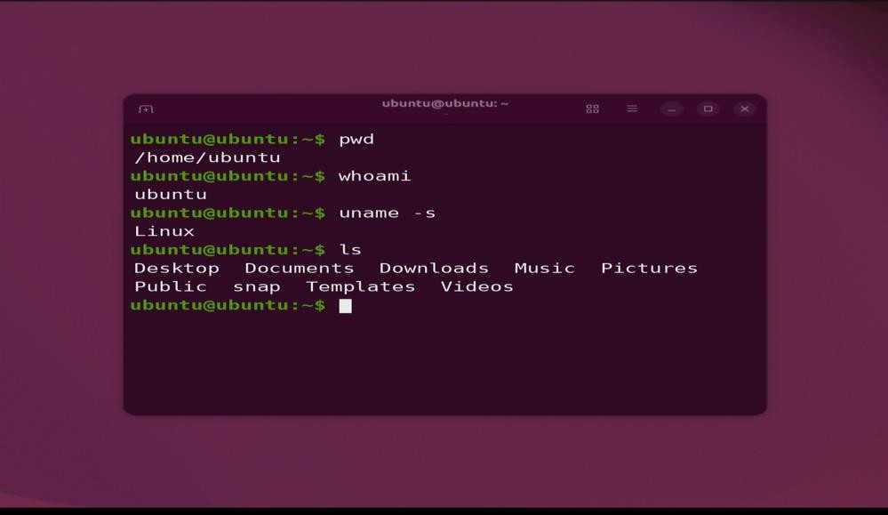

Step 9. Create a working directory using mkdir vm_lab, enter it using cd vm_lab, create an empty file using touch notes.txt, then check the location with pwd and its contents with ls.
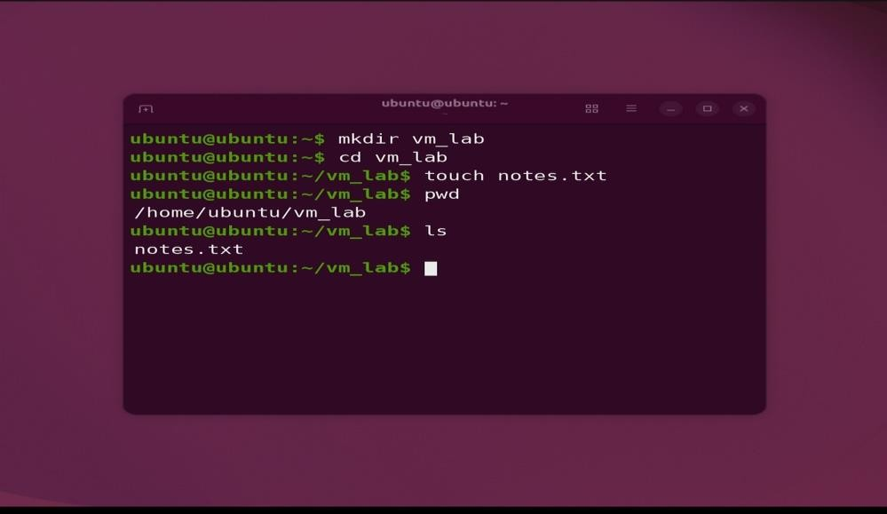

Step 10. Write a line with echo "VMware Ubuntu Lab" > notes.txt, display it with cat notes.txt, count its lines with wc -l notes.txt and copy it with cp notes.txt backup.txt.

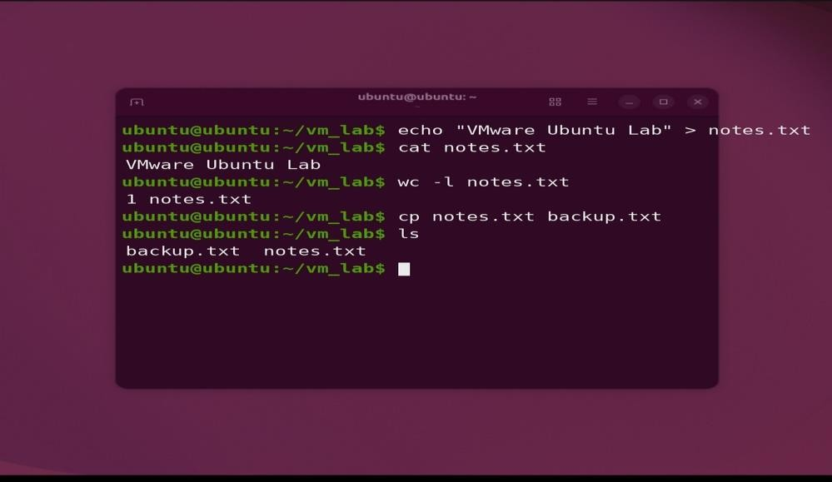

Step 11. Rename the copied file using mv backup.txt old_notes.txt; use ls to verify it. Delete the copy with rm old_notes.txt, then run ls to verify that only notes.txt remains.
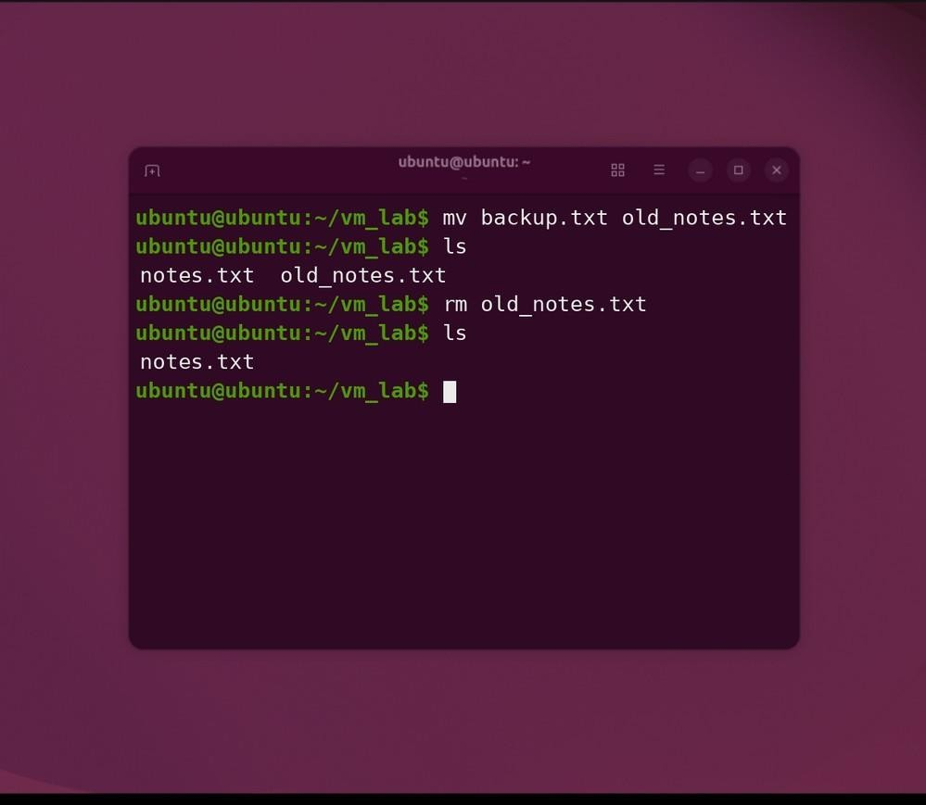

COMMANDS AND PURPOSE

Unix command | Purpose
pwd | Print current directory path
whoami | Show current user
uname -s | Show operating-system kernel name
ls | List directory entries
mkdir | Create a new directory
cd | Change directory
touch | Create empty file / update timestamp
echo > | Write text to a file (overwrite)
cat | Display file contents
wc -l | Count file lines
cp | Copy file
mv | Move or rename file
rm | Remove a file

OBSERVATION / VERIFICATION
Expected verification: A clone of the existing VM is shown in the VMware library with the selected hardware-compatibility level; Ubuntu boots successfully; the Unix commands execute without error and display the expected directory, identity, file creation, text content, and cleanup results. Confirm these results in your actual VM before recording the experiment as completed.

RESULT
The procedure to change the hardware compatibility of a preconfigured Ubuntu virtual machine, preserve its previous version by cloning, and run basic Unix commands was documented. The attached UI images and terminal transcripts are illustrative examples; actual successful execution must be validated on VMware

Workstation.

PRECAUTIONS
Power off the guest before changing compatibility. Keep the original VM or an independent backup. Choose a supported hardware version and check for limitations or VM device changes. Allocate adequate host space for the clone. Never use rm on unknown or important files. Replace illustrative Unix output screenshots with actual Terminal captures when submitting evidence of execution.

EXPERIMENTS 12–17 — QUICK VERIFICATION CHECKLIST

Exp. | Required Outcome | Verification
12 | VMware runs and Ubuntu guest boots | VM created; guest OS boot confirmed
13 | 1 CPU, 2048 MB RAM, 15 GB  virtual disk | Inspect VM Settings after saving
14 | Additional 15 GB VMDK attached | Check Hardware settings and Ubuntu lsblk
15 | Before Changes snapshot and restoration | Compare test file before/after revert
16 | Ubuntu-VM-Clone listed and boots | Verify clone separately from parent
17 | Hardware compatibility changed; Unix commands execute | Verify VM hardware version, boot and actual terminal outputs

IMPORTANT LAB RECORD NOTE
General precautions: save guest data before reversion or disk operations; keep sufficient host storage for snapshots and clones; safely shut down VMs; avoid duplicate IP addresses when running clones. Screenshots for Experiments 12–13 were supplied by the student. The diagrams illustrating Workstation menus and wizards in Experiments 14–17 were generated for teaching and formatting purposes; validate the precise controls against the installed VMware version before performing the procedures. Illustrative figures should not be presented as actual experimental execution evidence. Experiment 17 interface and Unix terminal images are also illustrative examples, not captures from the student’s VMware session.
Reference: VMware by Broadcom, Using VMware Workstation Pro 17 (2024), sections “Add a New Virtual Hard Disk to a Virtual Machine”, “Take a Snapshot of a Virtual Machine”, “Revert to a Snapshot”, and “Clone a Virtual Machine”. The generated wizard illustrations are approximate educational reconstructions, not actual captured execution screens; minor visual differences may occur between Workstation 17 builds. Further reference: Broadcom, Change the Hardware Compatibility of a Virtual Machine, VMware Workstation Pro 17 User Guide.

